USER MANUAL

For

Module: Student Self Service Portal

Introduction – Student Self Service Portal

The Student Portal provides students with a centralized platform to access and manage various academic, examination, attendance, and fee-related services. After successful login, students can perform multiple activities through a single dashboard without the need to visit the university physically.
Using the Student Portal, students can view and manage their profile information, track semester-wise academic progress, access attendance records, download admit cards, check examination results, and submit examination forms. The portal also enables students to view registration fees, examination fees, revaluation fees, back examination fees, miscellaneous fees, and continuation fees along with their payment status.
Additionally, students can monitor their academic journey through semester progression indicators, analyze fee-related information through graphical reports, receive important notifications and announcements, and quickly navigate to various student services. The portal is designed to provide a secure, transparent, and user-friendly environment that helps students efficiently manage their academic and examination activities from a single interface.

Login Page: This page is used to authenticate students and provide access to all academic, examination, attendance, profile, and fee-related services available in the Student Portal.


- Open the Student Portal URL. (https://studentportal.crsuiums.com/loginpage.aspx)
- Select the preferred login method (OTP, QR Code, or User ID).
- Enter the required credentials.
- Click Sign In.
- Upon successful login, the Student Dashboard is displayed.

1. Home Page: The Dashboard is the home page of the Student Portal that provides students with a quick overview of their academic progress, fee details, and important services.

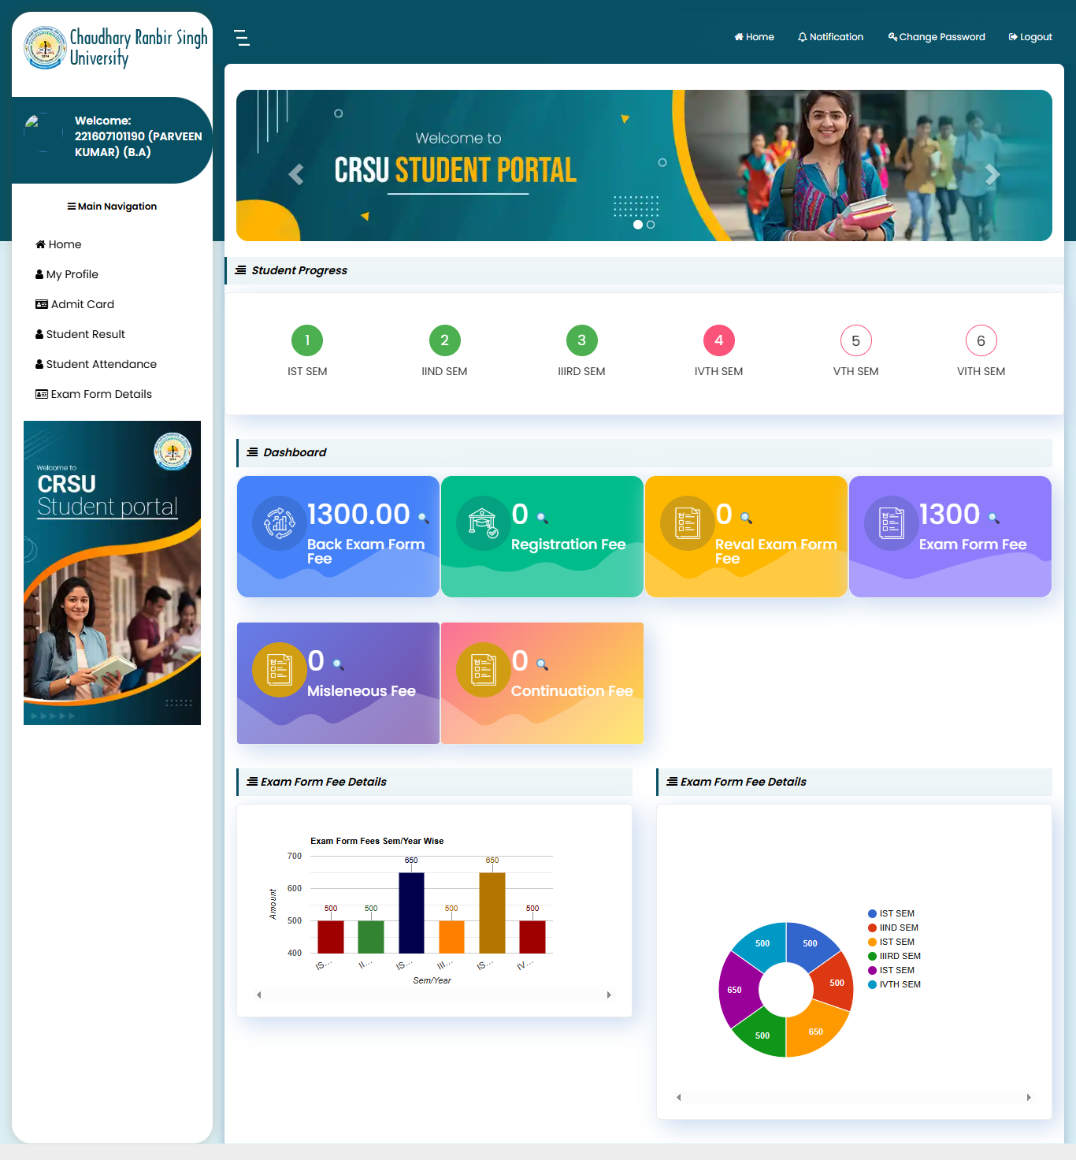

- Displays student profile information and course details.
- Shows semester-wise academic progress.
- Provides quick access to My Profile, Admit Card, Student Result, Student Attendance, and Exam Form Details.
- Displays Back Exam Fee, Registration Fee, Revaluation Fee, Exam Fee, Miscellaneous Fee, and Continuation Fee details.
- Shows graphical reports of examination fee information.
- Provides access to notifications and account management options.
- Enables students to monitor academic and fee-related activities from a single screen.
- Serves as the central navigation page for all student services.

  - My Profile: The My Profile page allows students to view their personal, academic, and address details maintained in the university records.

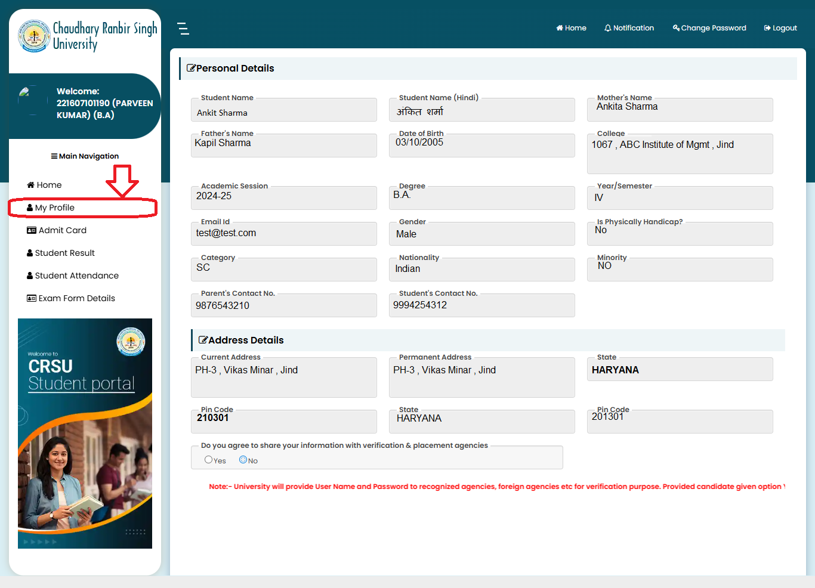

- Displays student personal information such as Name, Father's Name, Mother's Name, and Date of Birth.
- Shows academic details including College, Degree, Academic Session, and Current Semester.
- Displays student category, gender, nationality, and disability status.
- Shows registered Email ID and Contact Numbers.
- Provides current and permanent address information.
- Displays state and pin code details.
- Allows students to verify their profile information.
- Provides an option to consent to sharing information with verification and placement agencies.
- Helps students ensure that their university records are accurate and up to date.
- Serves as a centralized view of all student profile information.

  - Download Admit Card: This page allows students to view and download their admit cards for the respective examination session.

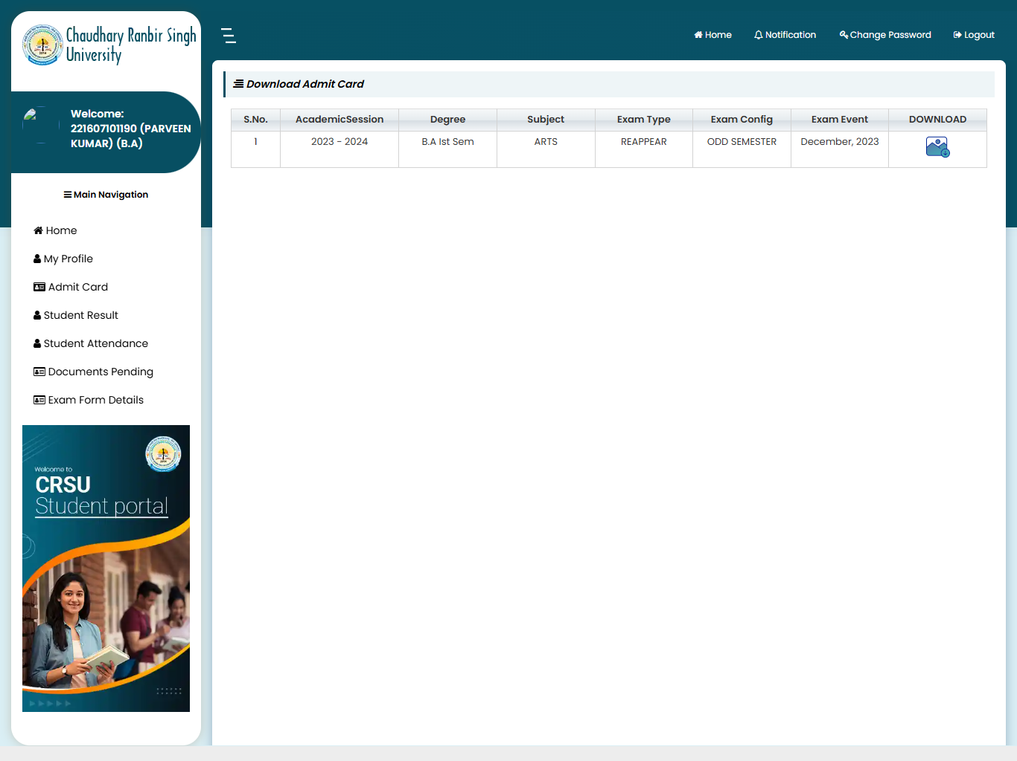

- Displays the list of available admit cards for the student.
- Shows Academic Session, Degree, Subject, and Examination Type details.
- Displays Exam Configuration and Exam Event information.
- Provides a download option for each available admit card.
- Click the Download icon to download the admit card.
- Verify all details mentioned on the admit card after downloading.
- Downloaded admit cards can be printed for examination purposes.
- Students can access admit cards only for eligible and approved examinations..

‘

1.3 Student Attendance Page: This page helps students track their attendance regularly and stay informed about their class participation status.

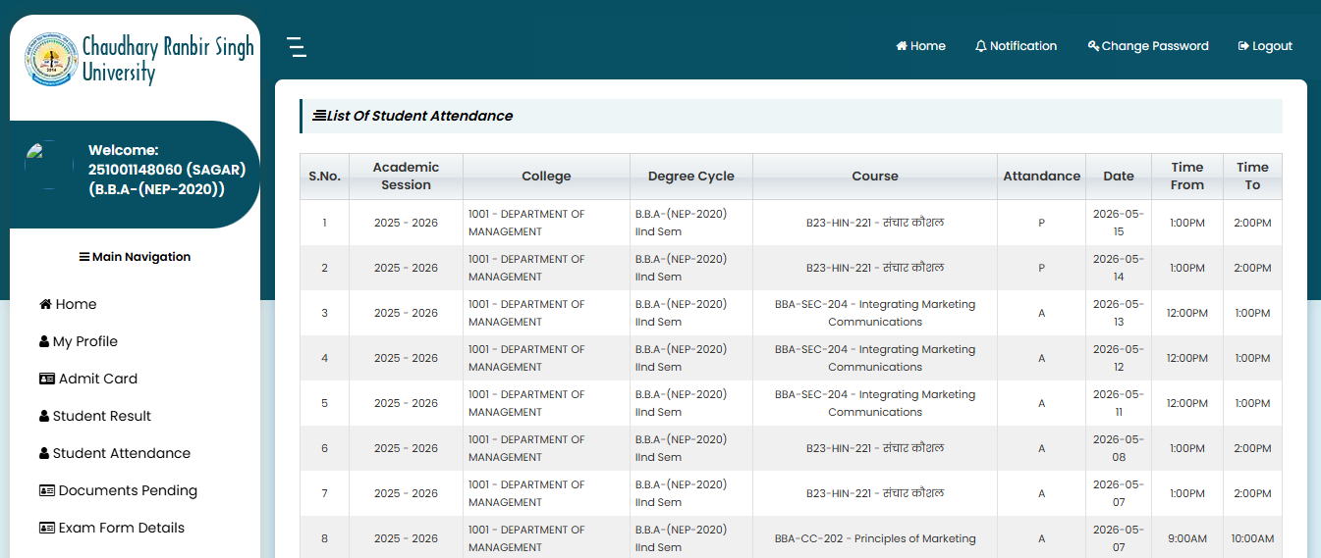

- Navigate to Student Attendance from the left-side menu.
- View the list of attendance records for the selected academic session.
- Check details such as College, Degree Cycle, Course, Attendance Status, Date, and Class Timing.
- Attendance status is displayed as:
- P = Present
- A = Absent
- Use the table to monitor daily attendance for each subject/course.
- Verify attendance dates and class timings for accuracy.
- Contact the department/administration if any attendance discrepancy is found.

  - Documents Pending Page: This page allows students to view the status of their submitted documents and identify any pending verification requirements.
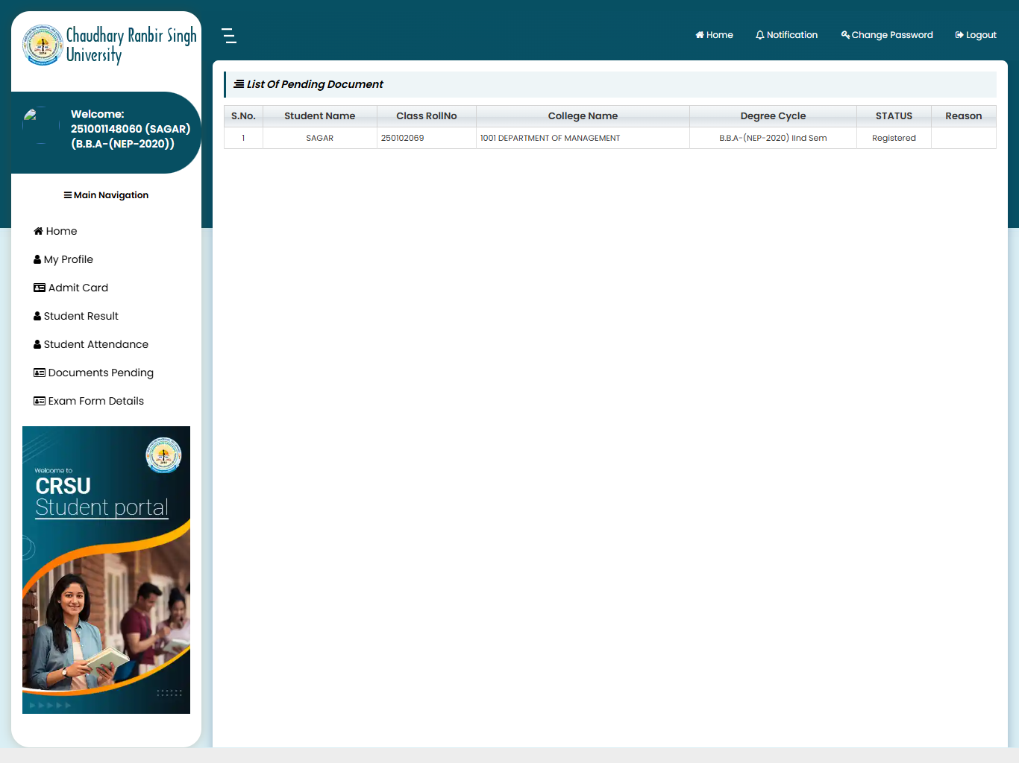

- Navigate to Documents Pending from the left-side menu.
- This page displays the list of documents required for verification.
- Review the following details shown in the table:
- Student Name
- Class Roll Number
- College Name
- Degree/Course
- Status
- Reason (if any document issue exists)
- Check the Status column to verify whether your registration/documents are approved or pending.
- If the Reason column contains remarks, follow the instructions provided and submit the required documents.
- If the status shows Registered and no reason is mentioned, no further action is required.
- Contact the college/university administration if any discrepancy is found in the displayed information.
- Regularly check this page for updates regarding document verification status.

  - Exam Form Details Page: This page enables students to view and download their submitted examination forms. It helps in verifying exam details such as session, exam type, and examination event, and serves as a record for future reference.

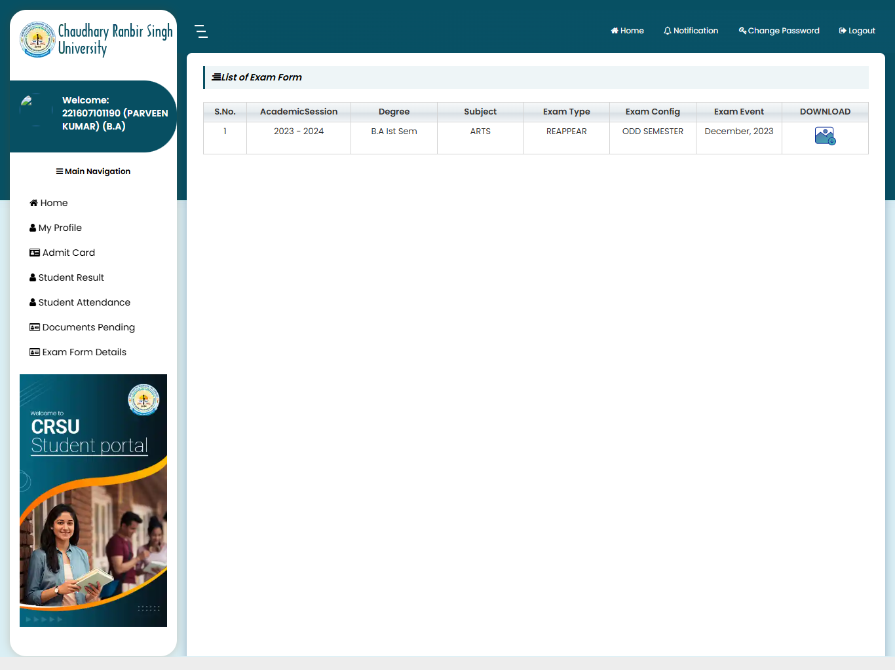

- Displays all submitted exam forms of the student.
- Shows Academic Session, Degree, Subject, Exam Type, Exam Configuration, and Exam Event details.
- Allows students to check examination form information for different sessions.
- Provides a Download option to download the submitted exam form.
- Helps students verify examination details before appearing in the exam.
- Maintains a record of previously submitted examination forms.
- Students can report discrepancies to the concerned authority if any incorrect information is found.

